***1. Dataset used:***

<https://www.kaggle.com/datasets/iamsouravbanerjee/cause-of-deaths-around-the-world>  
  
  
The dataset provides comprehensive information on causes of death worldwide from the year 2000 to 2019. It includes data on death rates and causes categorized by various countries. The dataset includes a wide range of causes of death including infectious diseases, chronic illnesses, external causes such as accidents and violence, and natural disasters.

The goal of using this dataset is to find patterns in the causes of death to help researchers, policymakers, and healthcare professionals identify areas of importance, evaluate the efficacy of public health campaigns, and develop strategies to lower mortality rates.

We have further divided the data between Chronic, Non-chronic illnesses and other factors, to help pinpoint more trends in our data and help analyze it in a more comprehensive matter. Furthermore, we have set a hypothesis that pollution plays a major role in most illness factors and some of the other factors, we will be collecting data for later phases to help support this hypothesis.

***2. Goals:***

1. Which Region and which country have the highest cause of death due to HIV/AIDS during 2000-2010?

2. Which region has the most deaths due to Respiratory Infections and Chronic Respiratory Diseases and do they increase or decrease together, which means they are directly related and is directly related to pollution rates?

3. Is there a direct relationship between deaths due to drug use disorders & alcohol use disorders and deaths cause by interpersonal violence?

4. Is there a direct relationship between deaths caused by Cirrhosis and Other Chronic Liver Diseases and alcohol use disorder and cardiovascular diseases?

5. Which countries have the highest number of deaths caused by digestive diseases and what regions do they belong to and is there a common region between them and is it directly related to pollution rates?

6. What other chronic illness have a direct relation between it and Alzheimer's Disease and Other Dementias.

***3. Insight:***

Q1.

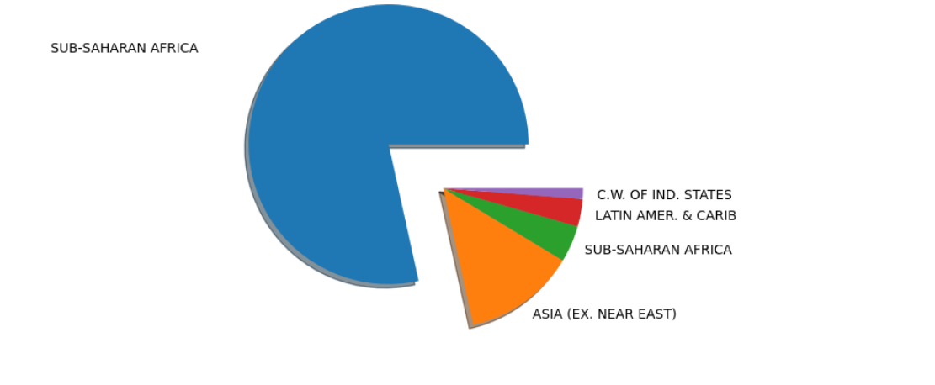

As shown Sub-Saharan Africa has the highest cause of death due to HIV/AIDS. Data given was sufficient to draw this insight and made this region outstanding compared to others.

From the bubble graph, highest country that suffers from HIV/AIDS is South Africa as shown in the visualization above. From data given, it draws a conclusion that South Africa stands out with a gap difference between it and other countries as shown. However, to rank other countries, more data would be sufficient to clear the tie between Kenya and Nigeria.

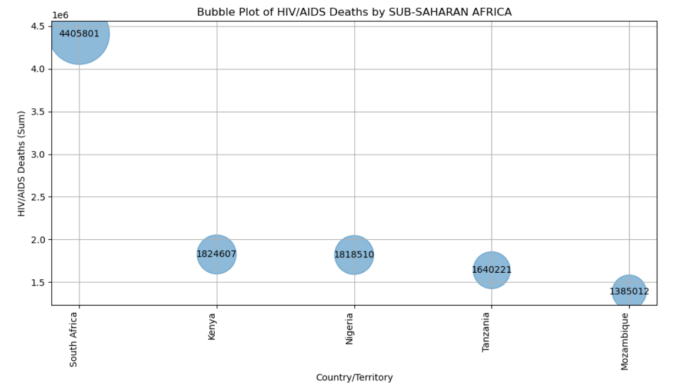

Q2.

From the graph the common region between the two highest countries, India and China is Asia.

Those two countries exceed the number of deaths caused by both causes other than any other country by a large margin and while these two countries share the same region and both have large numbers of death caused by Lower Respiratory infection and Chronic Respiratory diseases there is no enough data to confirm a direct relation between both diseases. On the other hand, they might have a relationship with pollution rates of these countries but this will require more data which is being gather by us to confirm that relationship

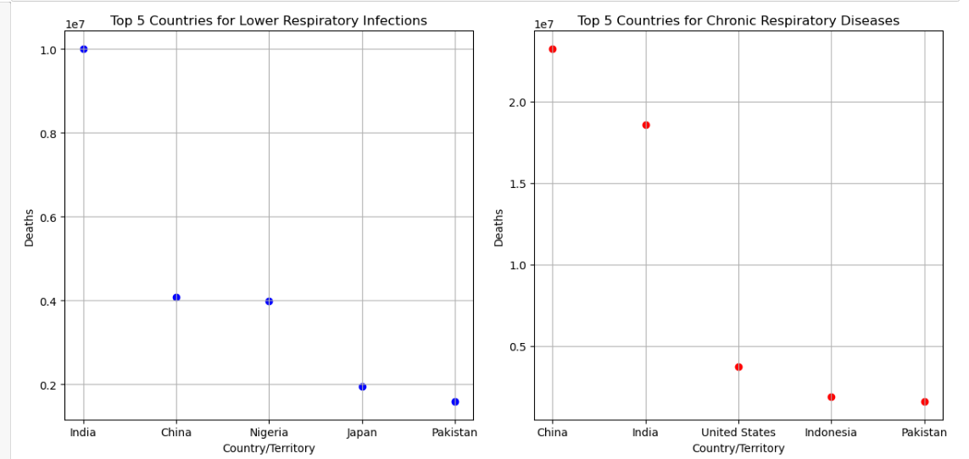

Q3.

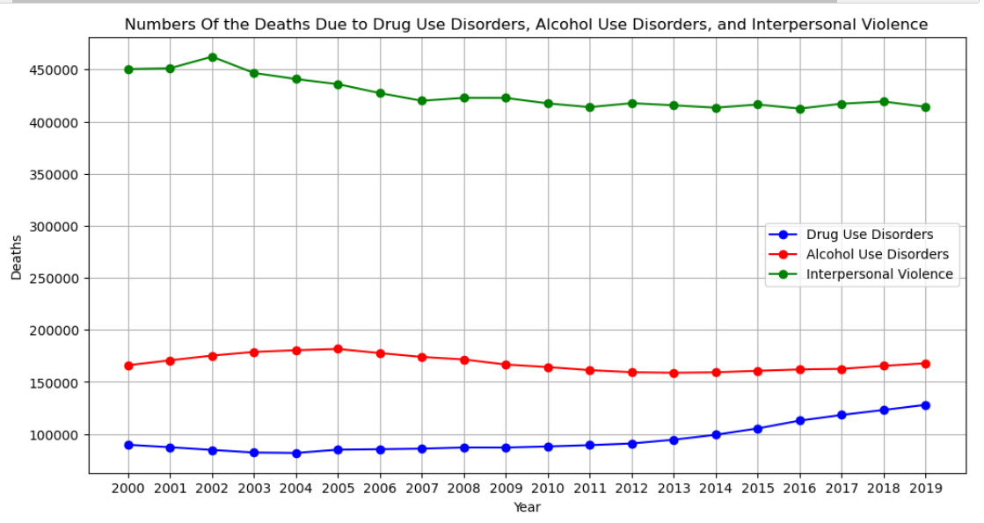

The graph shows that when Alcohol Use Disorders and Drug Use Disorders increase, Alcohol Use Disorders decrease (inverse relation), which is opposite to our hypothesis of a direct relation.

On the other hand, there might be a connection between substance use and less violent behaviour,

Despite that, other factors can affect these attributes. the graph can simplify things too much but leave out important details and context.

Q4.

Despite our hypothesis about Alcohol use disorder being directly related and increasing with other causes, the data over the last 19 years, we used doesn’t show concrete relationship due to the massive number of factors that affect all three causes independently. Therefore, we would need more data to find relationship between them.

On the other hand, the data does show a massive rise in deaths due to cardiovascular diseases in the last 19 years, which could be related to pollution or other factors that can be shown by collecting more data.

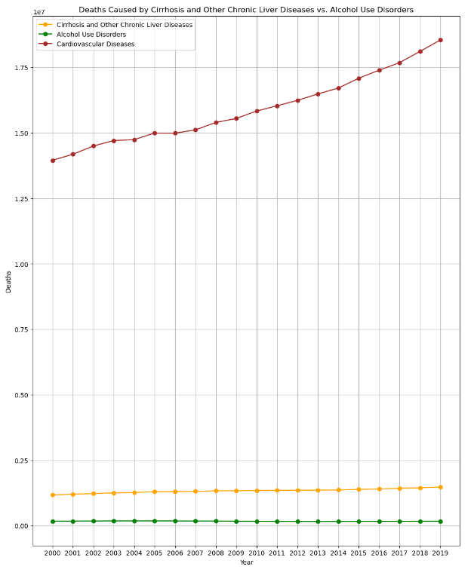

Q5.

India ranks first in terms of Digestive Diseases deaths, with a count of more than 450,000. China follows India in terms of the number of deaths, and Indonesia ranks third. (Pie Chart) By analyzing the pie chart Asia had the highest percentage (60.3%) of Digestive Diseases deaths among the top countries. This indicates that a significant proportion of Digestive Diseases deaths occur in Asian countries. The United States region accounts for 7.3% of Digestive Diseases deaths, suggesting a considerable number of deaths in that region. Latin America and the Caribbean also contribute 7.3% of Digestive Diseases deaths. Western Europe represents 7.9% of Digestive Diseases deaths. The remaining regions share the rest of the percentage. (Choropleth Map)

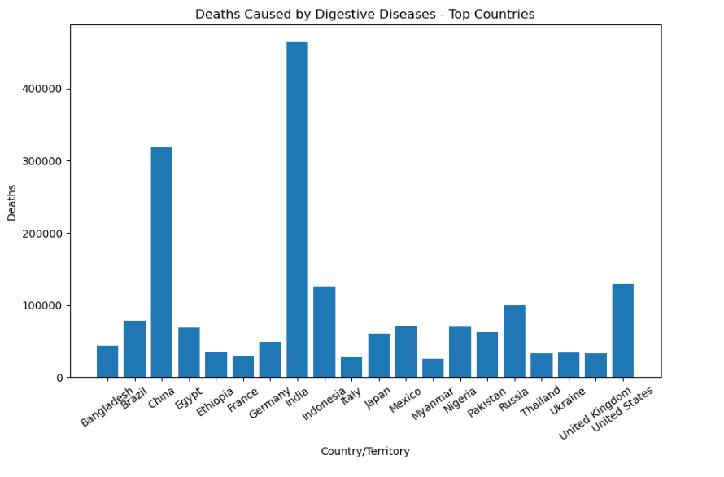

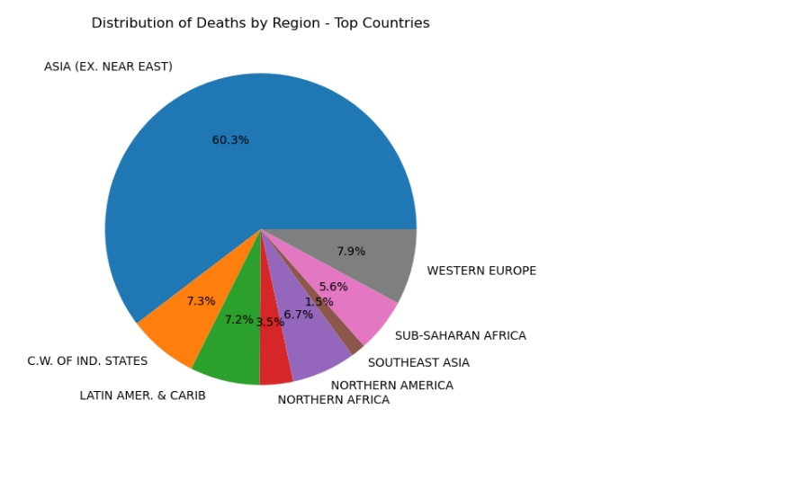

By analyzing the Choropleth Map we indicates that India is highlighted with yellow coloring on the choropleth map, indicating that it has more than 450,000 Digestive Diseases deaths. The color bar associated with the map provides a visual representation of the Digestive Diseases death count, where yellow represents a higher number of deaths. Finally, these observations suggest that India has the highest number of Digestive Diseases deaths among the mentioned countries, and Asia as a region has the highest proportion of Digestive Diseases deaths

While the relationship between this data and the pollution rates is uncertain, we are hypothesizing there is a directly relationship between the pollution rates in these countries with high numbers of deaths

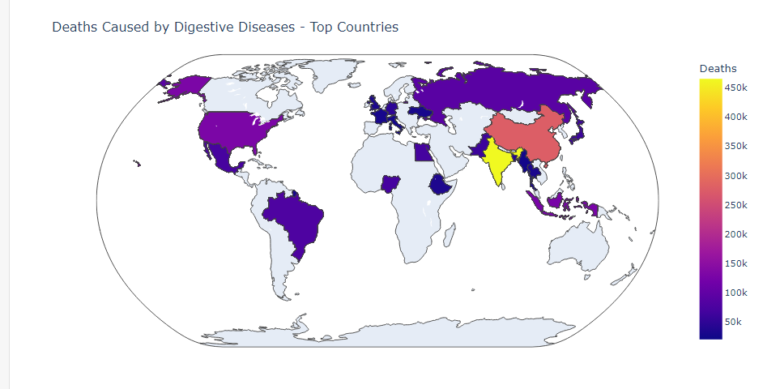

Q6.

As the heat map graph indicated, the top 3 chronic diseases related to Alzheimer's disease and other dementias are: Parkinson's disease (0.95), Neoplasms (0.93) and cardiovascular diseases (0.83). Rest of the chronic diseases such as HIV/AIDS show no correlation to Alzheimer indicating there is no relation between them.

